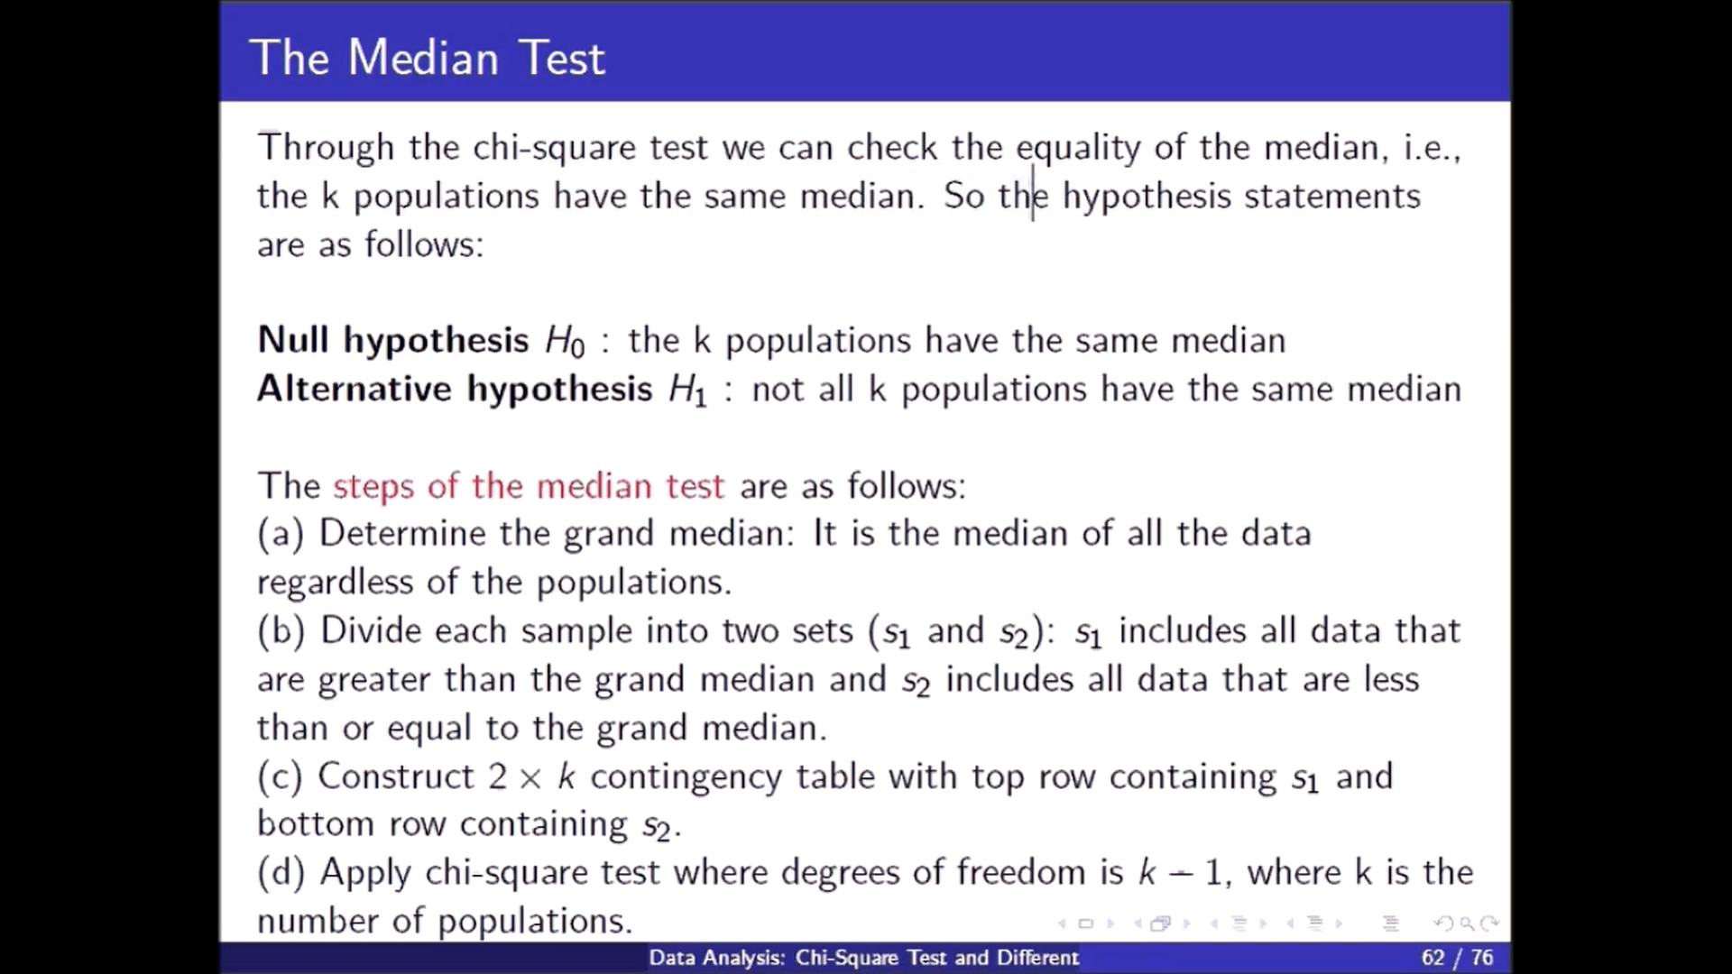

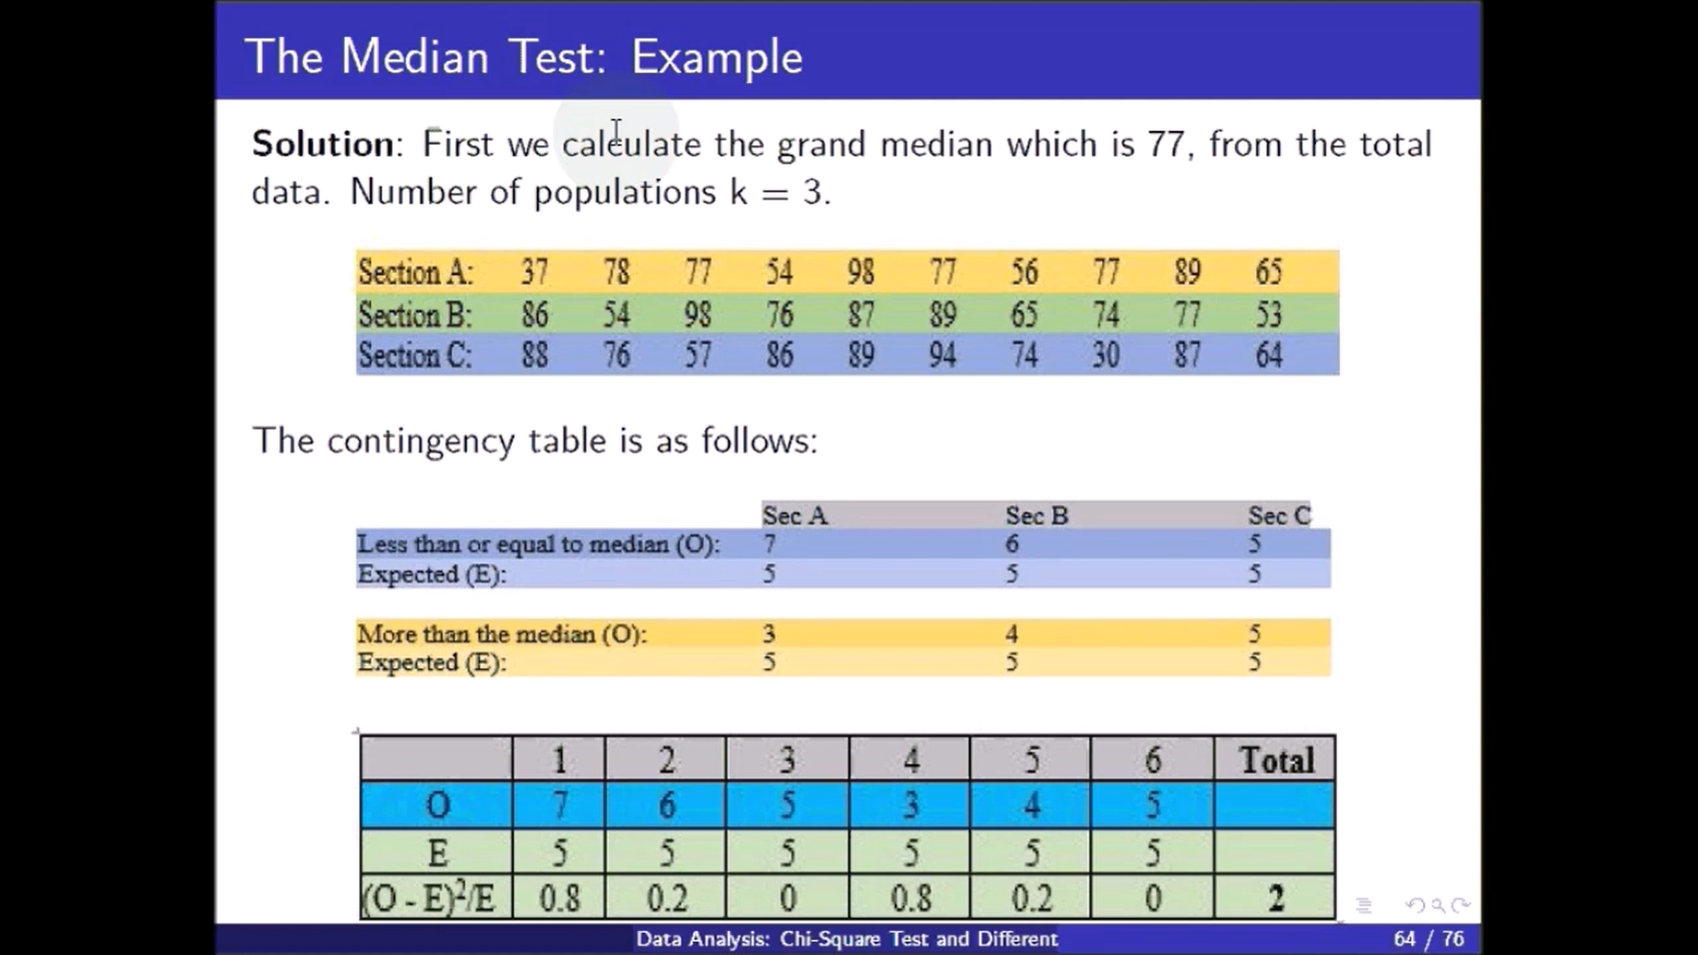

|  |  |  |  |
| --- | --- | --- | --- |
|  | Section A | Section B | Section C |
| Less than or equal to Median | 7 | 6 | 5 |
| More than the Median | 3 | 4 | 5 |

In statistics, Mood's **median test** is a special case **of** Pearson's **chi**-**squared test**. It is a nonparametric **test** that **tests** the null hypothesis that the **medians of** the populations from which two or more samples are drawn are identical.

The **median test** is a non-parametric **test** that is used to **test** whether two (or more) independent groups differ in central tendency - specifically whether the groups have been drawn from a population with the same **median**. The null hypothesis is that the groups **are** drawn from populations with the same **median**.